**ADG 7 - EXEMPT ACTIVITIES**

1.1.3.1.(d) & (e)

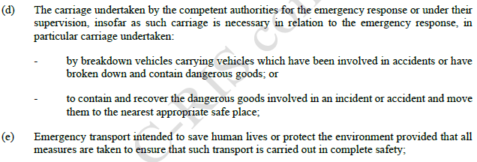

(d) above relates to exemptions for carriage for competent authorities for emergency response etc and assumes carriage is undertaken by the competent authority – it is more likely to be under their direction or with their approval. This should only apply to carriage under CA or delegate direction or authorisation, and the transport should only be exempted for necessary aspects of the code relevant to that specific incident, potentially with applied conditions set by the CA or delegate. Damaged and crashed DG vehicles are high hazard and should not be blanket exempted from all provisions of the code.

The use of the terminology “*by breakdown vehicles carrying vehicles* ie…” in the Australian context would likely be interpreted to mean tow trucks, tilt trays and the like. These operators should not have access to blanket exemptions from the code, and need to be exempted on a case by case basis in consultation with the relevant regulator / CA.

(e) above may be interpreted to give any entity the ability to contravene all provisions of the code without recourse to the CA or any other authority. This also should not occur.

1.1.3.1.(f)

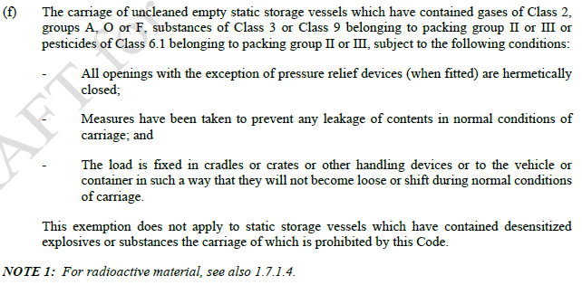

The above exempts empty “uncleaned” static storage tanks which have contained a range of specified DG from all provisions of the code, if the tanks are sealed and secured to prevent load movement in transport. That means no transport documentation, no placarding, no emergency equipment, no segregation from other DG on the same vehicle, no insurance and so forth. The load should at least have placards, paperwork and insurance in place, and other dangerous goods should be prohibited in the same load. It is noted that disused petrol and LP Gas storage vessels are within the scope of this exemption.

AFAC opposes the clause as worded above.

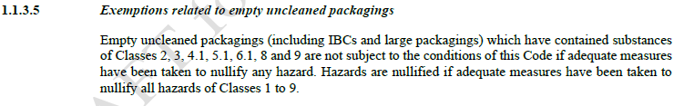

This exempts carriage of empty uncleaned packagings of a range of DG (e.g. including Class 6.1 PG I such as chloropicrin) if *adequate measures have been taken to nullify any hazard*. It is not clear what this means, or how it would be demonstrated. It is not clear how it would be enforceable preventatively, as opposed to after an incident which demonstrates that the hazard was not nullified. The last sentence is not helpful in explanation of nullification of hazards.

From an emergency services perspective the packagings need to be labelled as for any other packaging of DG, the operator should carry transport documentation – this then gives responders details of residues, contacts for consignor / consignee - which can expedite response, recovery and minimise risk to responders, the driver, the public and the environment, as well as expediting incident resolution.

AFAC opposes the exemption in 1.1.3.5 in its current form.

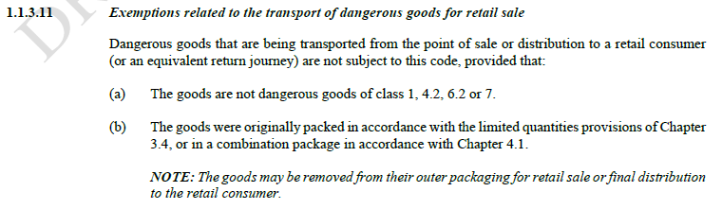



This section is listed in the RIS as providing “Equivalent treatment of home delivery services as private transport for low-risk domestic goods.” It exempts specified DG that are being transported from point of sale or distribution to a retail consumer (or an equivalent return journey) provided the goods were ***originally packed*** in accordance with limited quantity provisions or in a combination package. The term “retail consumer” is not defined, and the addressee is not limited to a residential address – so this seems to also be able to be applied to exempt commercial retail sales (e.g. laboratory chemicals) , hence exempting more than low risk domestic DG – particularly when it encompasses DG in combination packagings, which are not necessarily LQ, and may be PG I.

There is also the potential issue that returns don’t need to comply with the packing requirements, as the goods only had to be packed correctly when originally sent. Whilst industry is not using this process at the moment, the clause provides a mechanism where it can do so in future. AFAC opposes 1.1.3.11 as worded above. The associated risk may be readily addressed if the exemption were limited to ***products for domestic household use***.

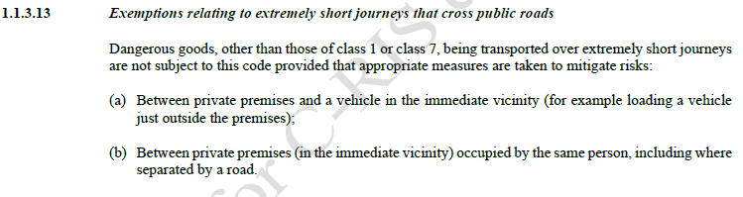

1. For private premises and a vehicle in the immediate vicinity (e.g. load or unloading a vehicle on the road outside the premises): this encourages sites not to design for loading / unloading on their own site, which increases risk. Loading / unloading DG on a road or in a public place should be discouraged and is generally more dangerous than on private property, in an area designed and laid out for it.
2. This provision could be used by a pastoralist or farmer to drive a DG load tens of km on a public road through or adjacent to their property/ies without complying with the code. (e.g. when the pastoral property straddles a public road, and the gate out of the property on one side of the road is many km from the gate into the property on the other wide of the road.) It is not unusual for such properties to be many tens of km long.

Irrespective of the distance covered AFAC would oppose (b), as it removes all controls required by the code at the discretion of the transporter, not the regulator. The decision as to what ***appropriate measures*** are to be taken would be the transporters decision, not the regulators / CAs.

It is noted that the above clause / provisions do not appear in either the current ADG, or the current ADR. It is not clear why it has been incorporated in the draft for the new code. It allows the use of containers / packages which are not approved, labelled, placarded. It does not require transport documentation, insurance, any emergency plan, equipment or PPE. This may lead to considerable avoidable risk to the public and responders in the event of an incident.

1.1.3.13 is opposed by AFAC.

**1.8 Checks and other support measures to ensure compliance with safety requirements**

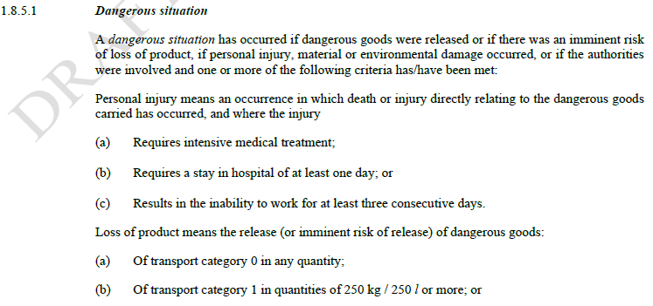

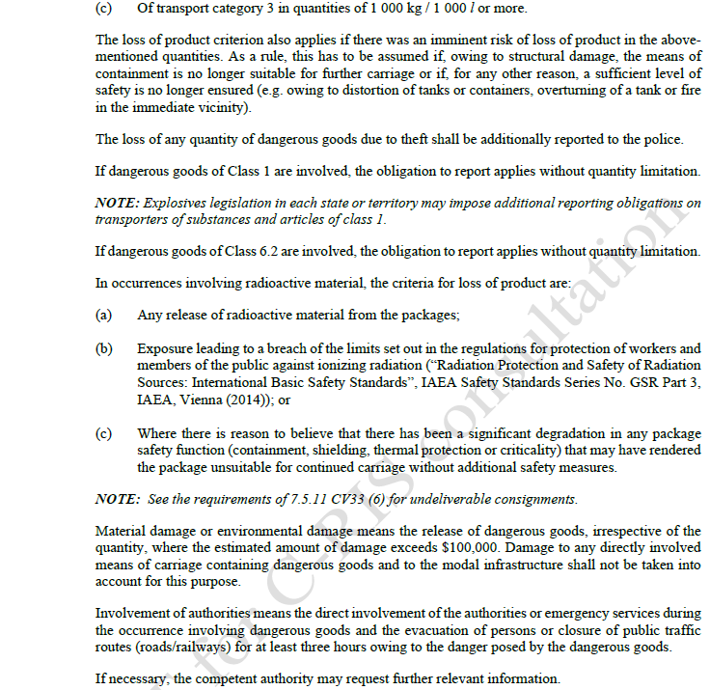

1.8.5.1

The above definition and criteria for a dangerous situation is divergent with existing definitions and legislative intent in various instruments, including in some jurisdictional DG parent Acts, WHS legislation and emergency management acts / legislation. An example where the above criteria would not address an incident when it results in a major impact and consequential loss / business interruption would be loss of mercaptans or tetrahydrothiophene where they are transport category 1, and the loss of product reporting threshold given above is 250 L. These odorants are not a major impact due to their flammability, but rather due to the downwind effect of the odorant causing belief there is a gas leak in the area. Given that a 1 litre spill in the southern metropolitan area of Perth resulted in building evacuations (shopping centres) approximately 30 km away, and in reports of gas leaks up to 50 km away it is clear that the loss of 250 L would be a significant incident.

It Is not clear why the cost of damage to the means of carriage or the modal infrastructure is not counted in dollar damage figures. This can and does rise into the millions and is very significant, as is the consequential loss due to closure of transport routes when infrastructure is damaged or destroyed. Not counting damage to the train or track system in a derailment, or to the truck, road, bridges etc for a road incident seems counterintuitive and contrary to quantifying impact of a significant incident.

It is also noted that there are 3 separate 1.8.5.1. (a) , (b), and (c) entries.

The criteria in the table should be revisited to align with reasonable expectations of what should be reported and investigated, or they should be left to state and territory regulators in jurisdictional statutes.

Separate statutory instruments cover Class 7 transport, this code should not cover what is / is not reportable for Class 7 transport.

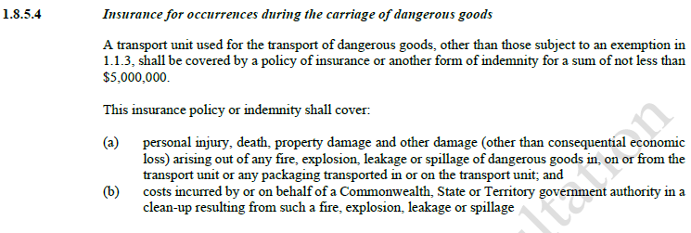

The insured sum of $5M for damage and costs incurred related to DG incidents is manifestly inadequate. This is a very low number, given non-DG public liability policies for road transport start at $20M, and many typical residential policies include $20M public liability cover.

A DG rail car incident in January 1958 Near Niagara Falls, New York injured 180 people and caused damage in excess of US$1M within a 3.5 mile radius. A similar incident about 4 months later at a siding near Mt Pulaski, Illinois caused about the same loss and two deaths.† That was ~US$1M (currently about AU$1.56M) about 66 years ago. Clearly a sum exceeding the equivalent of AU$5M today.

Inadequate insurance coverage leads to delays in transition from response to recovery, and delays in recovery, whilst pollutants (for example) are spreading in soil and ground water, and the problem is escalating. It is noted that ADG 6 (1998) required coverage of $1M for packaged loads and $2.5M for bulk loads. That increased to $2.5 M and $5M respectively when ADG 7 was introduced. This code, many years later, has not addressed increased costs of response and recovery, and associated insurance sums.

A more realistic sum may be $20M or more, this needs discussion and upward amendment. Some explosives industry transporters already have $50 M coverage. AFAC’s position is that a substantial increase to the insured sum is required – and this needs discussion with regulators, the insurance industry, responders, modal infrastructure operators (rail and road), and transporters.

†Charles W. Bahme, *Fire Officer’s Guide to Dangerous Chemicals*, NFPA, Boston, Mass., 1972, pg 103.

**1.10 Security Provisions**

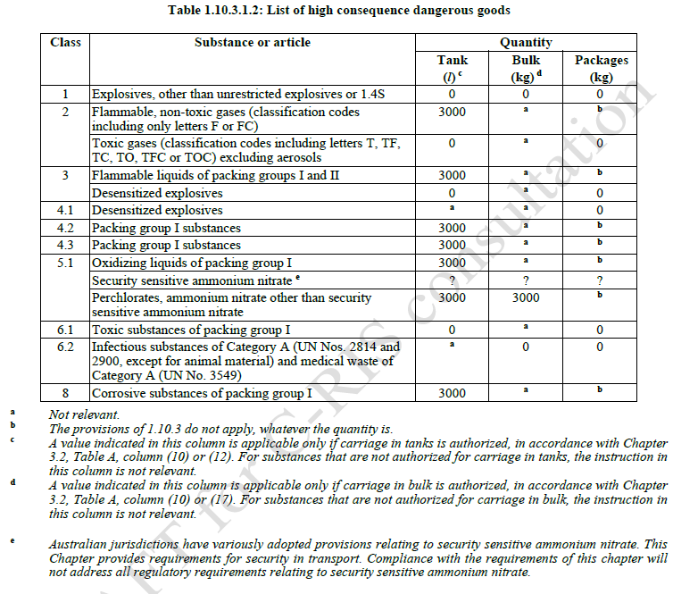

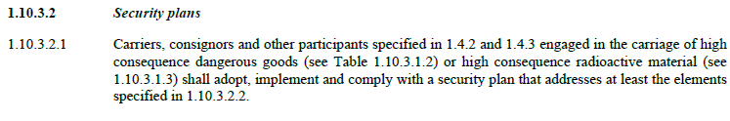

Some of the entries in table 1.10.3.1.2 differ from what may be expected. For example, reference to SSAN in 5.1 is problematic, in that various states and territories have differing legislation and potentially different thresholds for SSAN, so this would be difficult to set an agreed value on. Additionally, the application of security requirements to non SSAN ammonium nitrate seems out of place, as this material is non SSAN because it is so difficult to make an explosive from it.

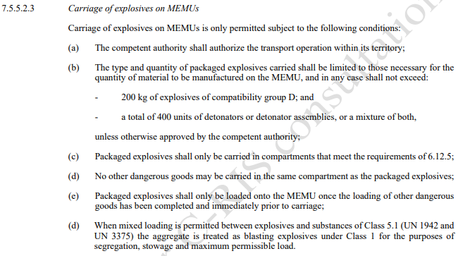

The carriage of explosives on a MPU (MEMU) on open roads defeats the original purpose for carrying UN 3375 instead of bulk Class 1 on a vehicle, as it provides a means of initiation on the vehicle, with the UN 3375 load. This increases the risk of detonation (e.g. in the event of vehicle fire), and may lead to either: (1) detonation when one may not have occurred in an incident, or (2) earlier detonation than would have occurred if the Class 1 material were not on the vehicle. AFAC opposes the introduction of this practice on public roads in Australia, as an avoidable and unnecessary risk to the driver, the public and emergency responders.

**Fire Extinguishers**

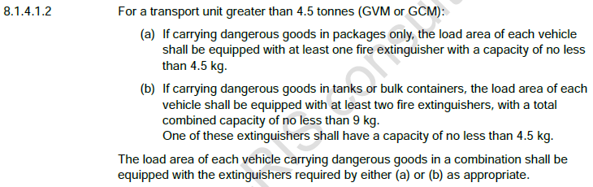

The 9 kg sum of extinguishers in (b) is unnecessarily complex and would allow a 4.5 kg and 5 x 1 kg extinguishers, for example. It should just be left that all load extinguishers are ≥ 4.5 kg, and (b) therefore requires at least two of them.

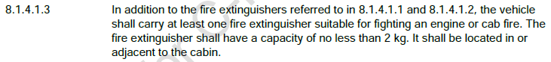

The cab fire extinguisher should be required to ***be immediately available to the driver alighting the cab***, not just in or adjacent to the cabin – which would allow it to be on the passenger’s side and external, requiring the driver to walk around the cab to the other side to get the extinguisher. This is not the intent. Some have been mounted in horizontal brackets inside the passenger’s door under the side of the seat on the floor – requiring the driver to alight the cab, walk to the passenger side of the vehicle, unlock / open the door, then remove the extinguisher from the bracket.



Add a requirement that water and foam extinguishers, where provided, shall be of 9 L capacity. Smaller extinguishers are not usually seen in Australia, but are marketed overseas, and are too small for this application. If smaller extinguishers are permitted in this application they may be imported for the purpose.

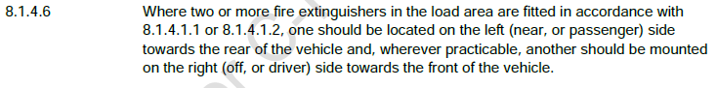

This wording is too conditional and rubbery, and allows other situations than what is required. Both occurrences of *should* should be replaced with *shall*, and the *where practicable* should be deleted. This needs to be mandatory and enforceable.

**8.1.5 Miscellaneous equipment and equipment for personal protection.**

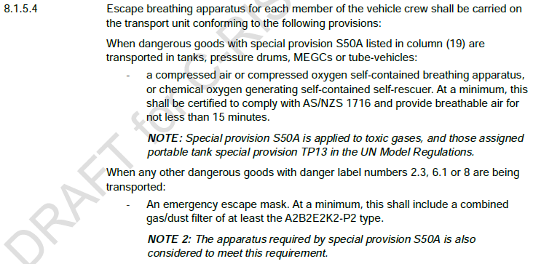

The use of a cartridge respirator or rebreather type self-rescuer doesn’t allow for eye protection which is provided by an escape BA set for materials producing irritant or corrosive fumes. These may cause severe eye irritation and possibly partial incapacity – impeding escape. This can occur for a range of 2.3s, Class 8s, (including some mineral acids, metham sodium / metham potassium), and also for 6.1s (including hydrogen fluoride, chloropicrin and others).

If self-rescuers or cartridge type respirators are used in this application, they need to provide eye protection from vapours / fumes etc. *e.g*. using a full face respirator. Additionally it has been assumed that a cartridge will be suitable for the potential situations. This is not clear, where concentrations of vapour / fumes in an incident may exceed the atmospheric concentrations the cartridge may be able to provide effective protection from. This is not the case with escape BA. Cartridge respirators also require initial and periodic face fit testing, enforced clean shaven policies and may be problematic for users with facial deformities, scars, smaller faces etc. The use of cartridge type air purifying respirators in this setting may contravene WHS law. It is also noted that whilst A2B2E2K2P2 is given as a minimum cartridge type, there are substances these cartridges may not provide protection from, such a mercury vapour (class 8) and carbon monoxide (from some carbonyls).

Escape BA should be reinstated as the requirement for all 2.3s, and for 6.1s / 8s where an irrespirable atmosphere may occur in an incident.

Am**monium nitrate vehicles.**



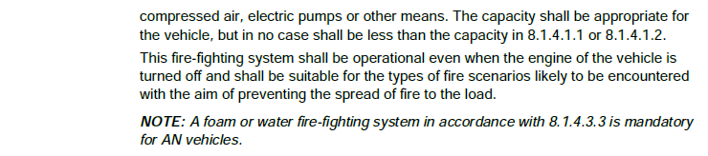

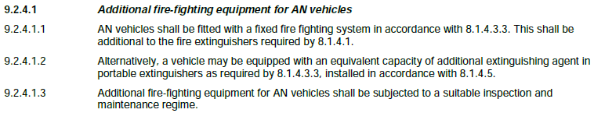

The above sections can be confusing, as the intent is to have both extinguishers and the system on AN vehicles (9.2.4.1.1) but it can be replaced with extinguishers (9.2.4.1.2), however 8.1.4.3.3 states that such a system may (in general) be provided in lieu of the extinguishers normally required.

The additional requirements for AN vehicles should be stand alone in section 9, and additional to the base requirements already given in Section 8, to avoid misinterpretation or misunderstanding.

Additionally, the capacity for a water or foam fire-fighting system referred to in 8.1.4.1.1 or 8.1.4.1.2. is too small (~9 L minimum equivalent). Such systems need a minimum capacity of the order of 50 – 60 litres. (probably easiest to match this with what is already in the marketplace).

For the NOTE: Make this mandatory for category 2 and 3 explosives vehicles as well as AN vehicles.

**Draft Dangerous Goods List**

**UN 0012 and UN 0014 both have 5kg LQ limited quantities listed in the DG List.**

This would see ammunition packed in packages bearing a LQ symbol, which does not adequately identify the hazard for firefighters, either in transport or storage. It is noted that the use of the LQ mark in transport will result in potentially very large inventories (far exceeding the 5 kg NEQ allowed in the draft ADG Code) bearing the LQ marking in storage and handling situations, where it is then not clear what the packages contain, and is not practicable in an incident (*e.g*. a fire) to readily identify what the packages contain. (i.e. which ones contain aerosols, which are ammunition, which are solvent based cleaners, which are paints and varnishes, which are metal surface treatment chemicals etc).

AFAC opposes the application of limited quantity provisions to ammunition (and Class 1 in general), as it reduces information immediately available to responding firefighters in an incident, and increases risk to responders and the public.

**WHS / DG Storage issues – AFAC Comments.**

**Removal of placards from IBCs (comment incorporates WHS and transport considerations)**

The draft ADG Code doesn’t require EIPs on IBCs, but treats them as packages.

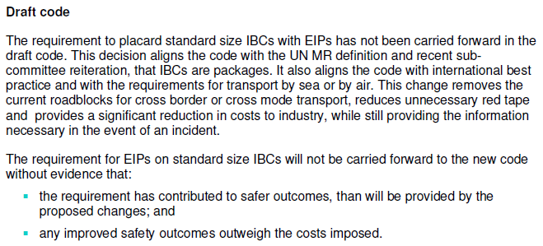

The model WHS regs, at Schedule 13, Clause 4(3) require a bulk placard on containers exceeding 500kg/L, including IBCs:

The reference in (d) above ceases to exist in the new ADG Code.

This leads to some options:

* Manufacturers / importers continue to require a bulk placard (or EIP instead) on IBCs at their workplace, so there is no change.
* IBCs arrive unplacarded at a workplace and the PCBU is required to apply a placard. Manufacturers and importers are likely to be better resourced to source and apply the correct placard than most workplaces.

WHS Regs Clause 350 exempts IBCs from requiring bulk placards where they are fitted with EIPs.

Again, the reference in (a) ceases to exist in the draft ADG Code.

Emergency response perspective of EIPs:

The purpose of the placarding under the WHS law is principally for emergency services to clearly, quickly and readily identify the DG and associated hazards on the site during an incident. This is similar for transport incidents. Composite 31HA1 IBCs of flammable liquids involved in a fire, for example, generally result in much faster fire escalation than a similar quantity of drums, as the rate of liquid loss and fire spread is much higher than for drums or other types of package. The labelling on a package (diamond and small text UN number) is much harder to see at a distance than an EIP, and hence is seen much later and when personnel are much closer to the hazard. It is key, for example, to distinguish between ethanol and hexane both of which are Class 3, PG II liquids, as the firefighting agents and techniques required are different for the two. The difference is readily identified on an EIP from the proper shipping name, UN number and HAZCHEM code. For IBCs and larger capacity containers this is critical for containment and fire suppression, whilst in some cases more generic techniques may work for smaller packages and quantities.

AFAC will accept EIPs on a vehicle and not on the carried IBCs, where all IBCs are of the same product, (e.g. as is common for ammonium nitrate prill or sodium cyanide loads) but does not support their sole use where generic / mixed load EIPs are used. The use of EIPs on the IBCs in this instance would be preferred, as firefighters would be working in SCBA, in some cases with glasses on, and potentially in an encapsulated suit (with visor) – all of which make it very difficult to read smaller text on labels, which require closer approach to the hazard. The example above is one of many that could be provided of the comparative benefit of EIPs.

**Removal of Divisions within Class 2**

ADG 7.9 uses the familiar Divisions:

* 2.1 Flammable gas
* 2.2 Non – flammable, non-toxic gas
* 2.3 Toxic gas

These have been replaced by a system of groups in the draft ADG Code:

Schedule 15 of the WHS Regs (MHF Thresholds) Table 15.2 refers to Division 2.1 which no longer exists in the new ADG Code:

Similarly WHS Reg 328(1) / Table 328 lists thresholds for regulating DG at non- workplaces by reference to Divisions 2.1, 2.2, and 2.3:

SDS are required in Section 14 to show the transport classification. As divisions no longer exist in the draft ADG Code a transport classification may be given as just “Class 2”, providing inadequate information, as the SDS code of practice doesn’t refer to “classification code”.

Many Australian Standards (especially those for storage and handling of DG), refer to gases by Division, often by reference to the ADG Code. These will need to be rewritten.

All of the above examples require consequential amendments to various codes, standards and legislative instruments outside of the immediate transport sphere, which will be a significant ongoing body of work.

**Goods too dangerous to be transported.**

The above term has been removed from the draft ADG Code and replaced by language from the ADR such as “prohibited for carriage” or “not accepted for carriage”. The Appendix A list of goods too dangerous to be transported is not in the new draft ADG Code. No comparison has been provided between the new draft and Appendix A of the current ADG Code.

MHF thresholds in Table 15.2 of the WHS Regs refer to “goods too dangerous to be transported” as listed in Appendix A to the ADG Code:

Schedule 12 to the WHS Regs, clause 3(c) requires the “goods too dangerous to be transported” name to be specified in manifests submitted to the regulator:

