Dear NTC,

My name is Leonard Hopgood. I am a road train fuel tanker driver from Darwin, NT.

I have held a Dangerous Goods licence and have worked in the transport industry for over 25 years. I am originally from Melbourne and previously worked in bulk chemicals cartage.

I have been in the Pilbara and now the Northern Territory for the last nineteen years predominantly carrying bulk refined petroleum products (ground fuels & aviation fuels) in that time.

For what it is worth I would like to make a brief (in comparison to the Code) submission with regard to the upcoming updating of the Australian Code for the Transport of Dangerous Goods.

Hopefully it will be reasonably coherent but if I could clarify anything please feel free to contact me at 0427 011 627 or [leonardhopgood@bigpond.com](mailto:leonardhopgood@bigpond.com)

**SECTION 5.3.6 PLACARDING ROAD VEHICLES**

“5.3.6.3.2.1 Except as provided in 5.3.6.4, emergency information panels, selected in accordance with 5.3.6.3.3, must be fitted:

(a) on the rear of a vehicle or vehicle combination on any part of which dangerous goods are carried in one or more bulk containers, tanks or placardable units; and

(b) on the sides of each trailer or rigid vehicle on which dangerous goods are carried in bulk containers, tanks or placardable units.”

There are then diagrams at 5.3.6 (b) showing the positioning of placards for “Road tank vehicles & combination road tank vehicles”

With a single trailer it is simple: the placards/EIPs go at the sides of the tanker (at the front) and a rearward facing one at the back (generally on the RHS)

Traditionally with B double combinations operators placed the placards at the sides (at the front) of each tanker and then the rearward facing one at the back of the combination.

Where there was a rearward facing placard/EIP on the lead (A) trailer this was left blank,

This appears to match the intent of 5.3.6.3.2.1.

However for road train operations and truck and dog operations it has traditionally been the case that the rearward facing placard/EIP at the back of the body truck or the lead trailer(s) has remained on display.

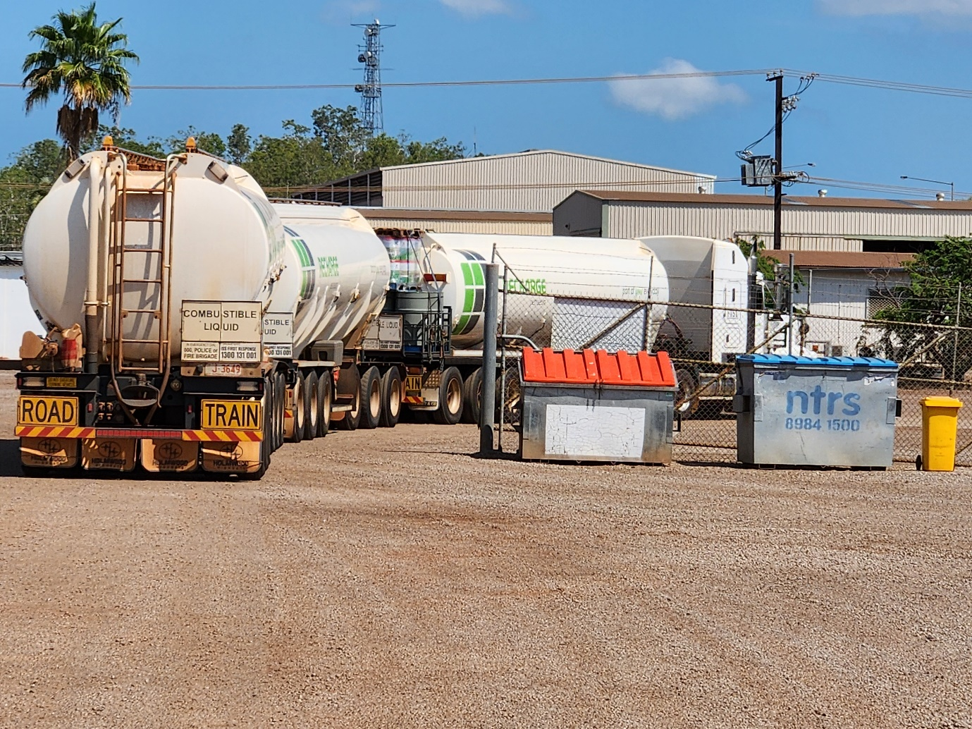

*Above: Traditional road train placarding with displayed EIPs at the rear of each unit in the combination*

The text of the regulations doesn’t specifically seem to exclude this (although it does state “the rear of a vehicle or vehicle combination” rather than “the rear of a vehicle AND/OR vehicle combination”) while the pictograms at 5.3.6 (b) do not show an option of having additional rearward facing placards/EIPs other than at the rearmost point of the combination.

I believe there may have been some changes in this area (5.3.6) in 2018. If so there doesn’t seem to have been much education for the industry in terms of this placarding arrangement changing or for what reason.

In my experience in WA and the NT it appears that very few operators have transitioned to the current placarding format – nearly all road trains have a displayed rearward placard/EIP on each and every trailer.

The operators that do display the rearward facing placard/EIP ONLY on the rearmost trailer seem to be fleets with a large presence in Queensland – perhaps the education and enforcement programs have been different in that jurisdiction?

Could we please have some additional clarity as to whether it is permissible to have additional displayed placards/EIPs on each unit of a combination vehicle or if it is specifically prohibited.

**DANGEROUS GOODS LICENSING & COMBUSTIBLE GOODS**

I am not in favour of diesel being classified as a Dangerous Good. However I believe that to transport diesel in bulk you should be required to hold a Dangerous Goods licence.

Curiously, it is not uncommon to deliver to sites that have placarding stating that their stored diesel is a flammable liquid (Class 3) with the UN number 1202.

Currently bulk diesel is in an awkward position in that it is a placarded load in as much as we must display “COMBUSTIBLE LIQUID” Emergency Information Panels (EIPs).

The presence of diesel also the changes the signage that may otherwise be required – ie; using “UN1270 PETROLEUM FUEL” signs where diesel is loaded with “UN1203 PETROL” or “UN1863 AVIATION TURBINE FUEL”.

Frequently in training programs we are encouraged not to underestimate the potential hazards of diesel, particularly as it is a static electricity generator/carrier, yet it in many ways it is formally considered to be as inert or innocuous as milk or water. It may, for instance, be allowed to travel in tunnels where Dangerous Goods are prohibited.

In recent times the overall transport industry has been experiencing a driver shortage. One effect of this that has been observed in the fuel cartage industry is that drivers without DG licences have been employed to cart only diesel.

Often times these are semi retired drivers who have previously held a DG licence and are familiar with traditional or historic industry practices, other times they are new entrants that have never held a DG licence and have limited training and experience.

What is then observed is that these drivers that do not hold a DG licence will then be loading from Dangerous Goods gantries (often country depots) and delivering to Dangerous Goods sites (ie service stations). They might also be carting bulk diesel, perhaps more than 100,000 litres, alongside hundreds of litres of packaged dangerous goods (ie 200 litre drums of petrol or avgas or Jet A1).

I am not suggesting that any of this is in anyway illegal or against the spirit of the regulations.

My suggestion is that we have an opportunity to lift standards. That is to require persons transporting bulk combustible liquids to hold a Dangerous Goods licence. These are cargoes that require Emergency Information Panels to be displayed and are predominantly diesel but also include some oils and other products.

I feel many stakeholders would already be of the expectation that fuel tanker drivers, especially those pulling multiple trailers, would hold a Dangerous Goods licence, have the requisite training and medical assessment that would entail, and travel the same routes as a fuel tanker carrying Class 3 flammables.

**INTERACTION BETWEEN BULK & PACKAGED DANGEROUS GOODS**

I work as a driver of a road train fuel tanker and I tow three trailers. The lead trailer has a drum rack at the rear that can hold two pallets of freight – this drum rack is a very common addition to fuel tankers in the north of the country.

*Below: A typical fuel tanker with pallet width drum rack fitted at the rear*

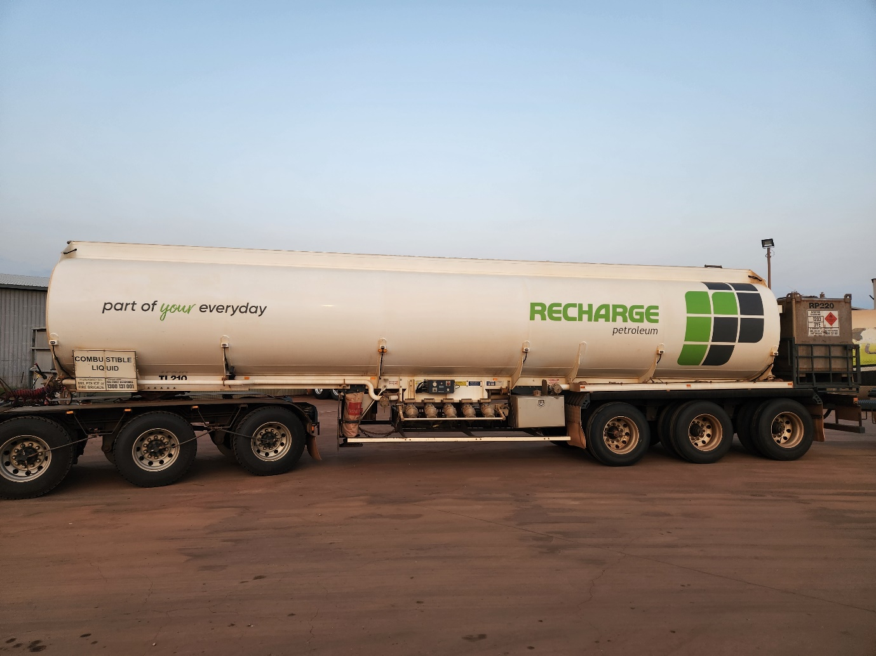

*This third tailer has an unusually large drum rack fitted*

The drum rack will accommodate up to eight 200 litre drums, these are often drums of petrol, aviation gasoline or Jet A1 – all Class 3 flammables.

Eight drums would be 1,600 litres.

The rack could also hold two Intermediate Bulk Containers or pods, these vary between holding 1,000 litres and 1,450 litres, often of aviation gasoline – UN1203 Class 3 (same as petrol).

Oftentimes the three tankers will hold all diesel, then the packaged flammables are the only Class 3 items on the road train.

As an aside, in some ways I feel that carrying packaged flammables with bulk diesel is akin to transporting the matches with the firewood.

In our industry we encounter a difficulty where packaged Dangerous Goods intersect with bulk loads.

The freight that is loaded onto these drum racks too often becomes “forgotten freight” or “invisible freight” in that it is loaded and then there is no signage in recognition of the drum rack freight, or it’s interaction with the bulk cargo.

It is frequently the case that if the quantities of the drum rack freight had been loaded into the tanker unit then signage/placarding would have been displayed without question but this is neglected where the freight is in separate drums or pods on the same trailer.

Excuses include that the drum rack freight “is not significant”, “it’s a grey area” with regard to the regulations or that there is no enforced or expected standard in operation.

To be honest, I struggle with the regulations for packaged dangerous goods and I have held a DG licence for a long time.

It used to seem simpler – more than 1,000 litres or kilograms was bulk, less was packaged. Bulk was EIPs, packaged was diamonds on display .

Now there seems to be a myriad of exemptions and complex regulations: domestic consumption exemptions, DGs packed in Limited Quantities or Excepted Quantities.

I would like to see simplification in the regulations pertaining to packaged Dangerous Goods (we are talking about the fast moving logistics industry and truck drivers more particularly) but I have no idea how we might go about pruning that tree.

What I would like to see from the code as it pertains to bulk fuels carrying industry are the two following items:

* Explicit recognition that a drum rack (or other cargo carrying component) attached to a tanker is a part of the overall trailer and that bulk Dangerous Goods loaded onto such a rack must be recognised by way of the placards/EIPs fixed to the trailer (one each side at the front and one at the rear).

That is to say that where bulk Dangerous Goods are loaded onto a drum rack this should be reflected through the existing placards/EIPs rather than relying only on any other signage that may be on the bulk container loaded onto the drum rack.

*Below: In this image we see a bulk container (greater than 1,000 litres) loaded onto the drum rack. The EIP on display reflects the diesel loaded in the tanker although the placard itself is attached to the drum rack.*

*There is no corresponding rearward facing placard for the bulk aviation gasoline that is loaded on the drum rack.*

*This could be a confusing arrangement for the average observer.*

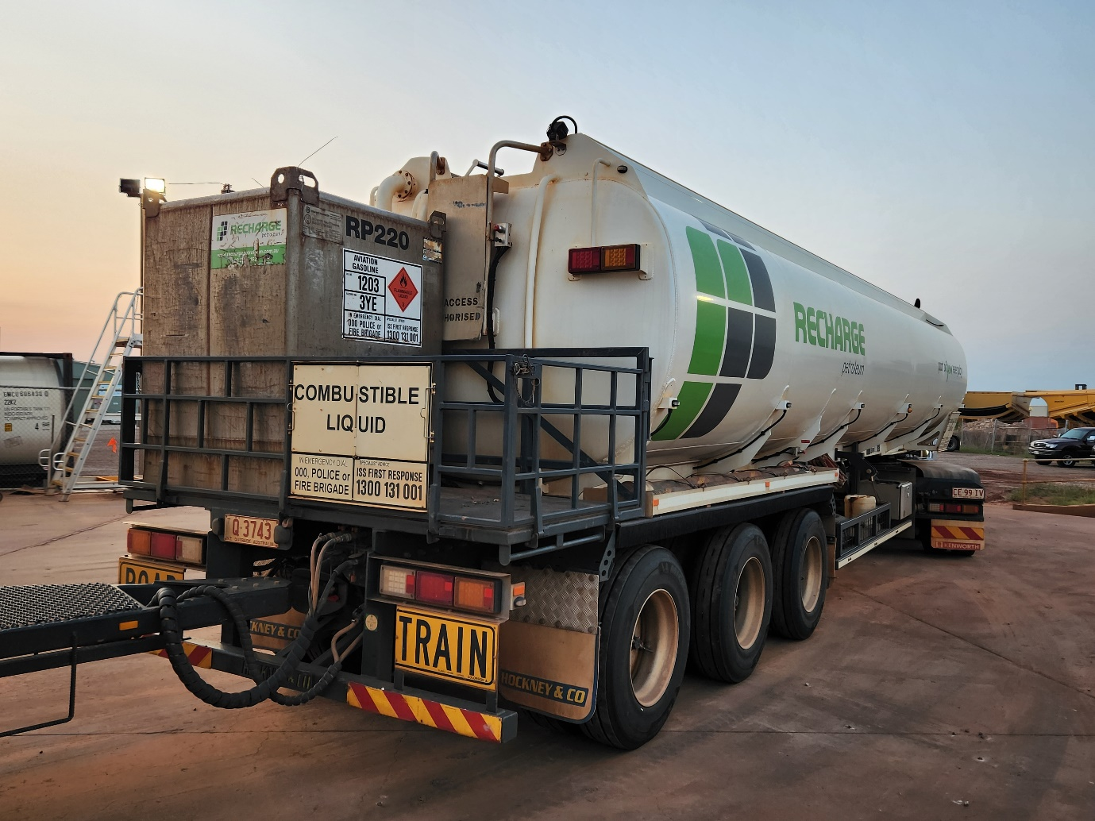

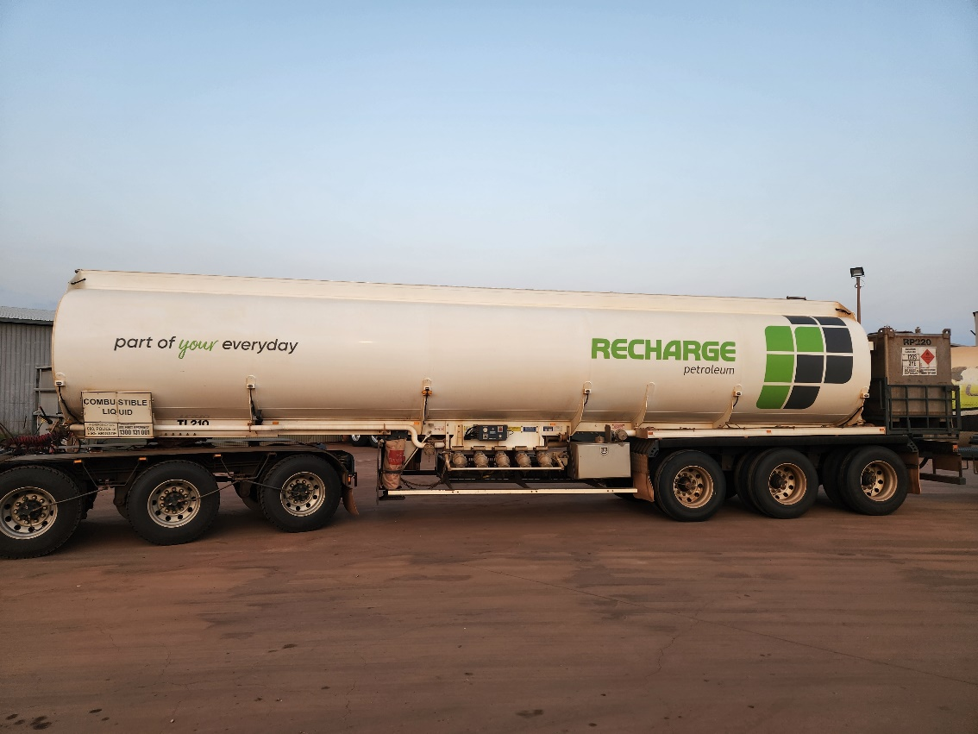

*Above: The side view of the same tanker/trailer. The standard sized EIP on the tanker reflecting only the diesel in the tanker, the undersized EIP* (allowed as per “5.3.3.5 Despite 5.3.1.3.5, if a placardable unit has a capacity of not more than 3 cubic metres, an emergency information panel fixed to the unit may have dimensions not less than half those shown in Figure 5.3.21 in which case the size of each label and the height of lettering and numerals on the panel must be reduced in proportion to the reduced dimensions of the panel.”) *on the portable bulk container reflecting only the aviation gasoline loaded within itself.*

*My preference would be for the three full sized EIPs (sides and rear, if applicable) to reflect the combination of bulk freight on the entire trailer unit. In this case it would mean displaying UN1270 PETROLEUM FUEL EIPs*

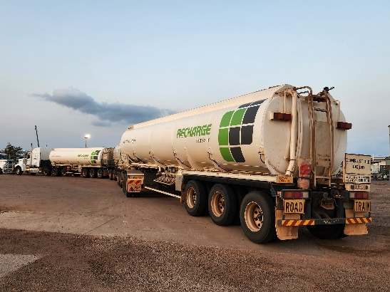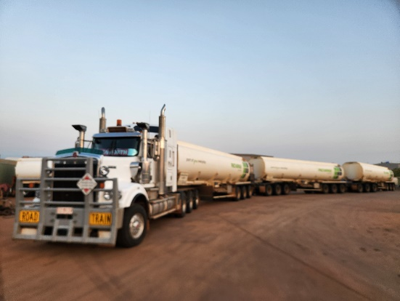

*Above: The forgotten freight – although there is bulk aviation gasoline (Class 3 UN1203) loaded onto the drum rack of the lead trailer no placarding indicates it’s presence at either the front or rear of the combination (apologies for the poor quality photograph)*

* Where packaged Dangerous Goods are loaded onto the drum rack of tanker otherwise carrying a load requiring the display of placards/EIPs then for the purposes of signage the packaged Dangerous Goods should be treated as though they were bulk Dangerous Goods.

Drums of petrol are packaged Dangerous Goods regardless of their number. Where eight are loaded onto a drum rack the regulations would suggest a red Class 3 diamond should be displayed at the sides of the drum rack (as per diagrams at Figure 5.3.6 (e)) and also at the front and rear of the vehicle/combination.

This does not tend to happen in practice and I have never seen a drum rack with a provision to display class label diamonds at the sides.

If the tanker were otherwise carrying diesel it would have a Combustible Liquid EIP at the rear and no other provision to display a red Class 3 diamond.

What is sometimes seen in practice, and what I suggest be formalised, is that in this example, where Class 3 packaged Dangerous Goods are loaded onto a drum rack of a tanker otherwise loaded with diesel, the placards/EIPs on display change from being Combustible Liquid - reflecting only the diesel, to Class 3 UN1270 Petroleum Fuel – to include the packaged Class 3 Dangerous Goods.

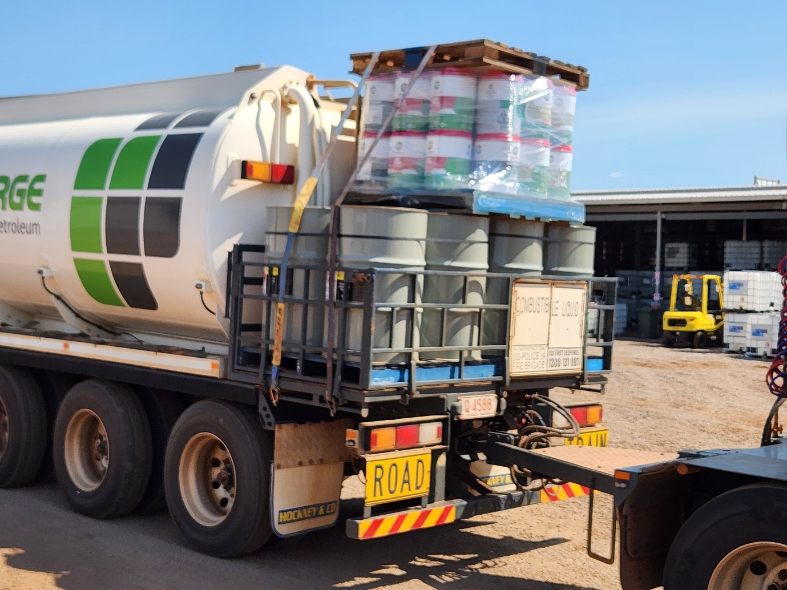

*Above: Packaged Dangerous Goods loaded onto a drum rack of a lead trailer otherwise carrying bulk diesel. The packaged freight includes eight drums of unleaded petrol.*

*No part of this combination displays any placarding (class diamond or EIP) in reference to the flammable packaged Dangerous Goods. In fairness to the driver they may not hold a Dangerous Goods licence and under the current regulations would not be required to do so.*

I am sure you have had a great many submissions of better quality but I thank you for the opportunity to get these things off my chest.

In my part of the world there are many fuel tankers operating but we don’t see a great number of other bulk Dangerous Goods vehicles. There are gas tankers and acid tankers and the odd chemical load but fuel tankers would be the vast majority of the Dangerous Goods tankers on our roads. Hence the fuel industry-centric nature of my submission.

My only other suggestion would be that the NTC liaise with the good people at Safe Load Program (SLP) as they have a very practical understanding of the fuel and fuel transport industry. I am sure would have a much broader view and better understanding of the impact of the Code on the fuels industry, where the pressing issues are and how best they could be resolved.

Please disregard any transport company branding visible in the photos. My submission is in regard to wider industry issues and is not specific to any one organisation. From my experience I would suggest that any of the practices observed are industry wide and not company specific.