ADG Submission – webform

Email: [linda.grannas@demirs.wa.gov.au](mailto:linda.grannas@demirs.wa.gov.au)

5.8.1.1No comment at this stage

5.9.1.1No comment at this stage

5.10.1.2.1No comment at this stage

5.10.2.1.1No comment at this stage

5.10.2.2.1No comment at this stage

5.10.2.3.1No comment at this stage

5.11.1.1No comment at this stage - still going through the details

5.12.1.1No comment at this stage - still going through the details, it is many years since I had involvement with review of DG tank design matters for the Victorian DG safety regulator

5.13.1.5I don't transport. My attached document refers to apparent ambiguity arising in the current draft wording in NOTE 2 of 2.2.3.1.1 in 'By derogation'...

5.13.2.1No comment at this stage

5.13.3.4Not applicable

15.3.4.1No comment at this stage

15.3.5.4No comment at this stage re Qs 53-62

5.13.6.4No comment at this stage re Qs 63-65

6.2.2.4Unsure - my employer is the state government regulator for various DG safety matters

6.2.2.5Not applicable

6.3.2.3No comment at this stage

6.3.2.4No comment at this stage

6.4I'm only providing comment here re the attached document - I'm not representing my employer

6.4.1.2I'm only providing comment here re the attached document - I'm not representing my employer

6.4.1.3I'm only providing comment here re the attached document - I'm not representing my employer

6.5.1.1I'm only providing comment here re the attached document - I'm not representing my employer

crm_id{Empty}

First name: Linda

Last name: Grannas

Email[linda.grannas@demirs.wa.gov.au](mailto:linda.grannas@demirs.wa.gov.au)



Attention – NTC re ADG Code Review Re 1.1.3.12 Exemptions relating to the transport of diesel

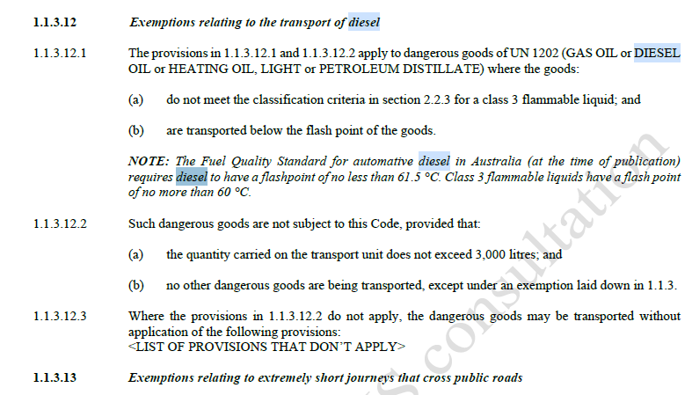

+ NOTE 2 below’s word ‘derogation’ [Derogation - Wikipedia](https://en.wikipedia.org/wiki/Derogation) allows for partial repeal (or abolition) of a law. So NOTE 2 seems to say that diesel – even if flash point is >60°C & < 100°C **is deemed a Class 3 , UN1202.  I think they meant to write (note I’m not a lawyer…..):  *NOTE 2:*** *By derogation from paragraph 2.2.3.1.1 above, diesel fuel, gasoil, heating oil (light) including synthetically manufactured products having a flash-point* ***above 60 °C*** *and not more than 100 °C shall* ***not*** *be deemed substances of Class 3, UN No. 1202.*

